**Connection between Azure and AWS through VPC**

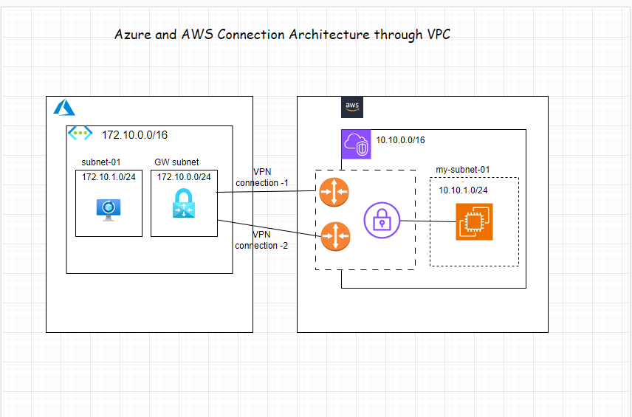

**Configuring Azure**

1. Crate a resource group on Azure to deploy the resources on that

Resource Group Name: rg-azure-aws

Region: East-US

2. Create Virtual Network

Resource Group Name: rg-azure-aws

Region: East-US

VNet Name: vnet-azure

VNet IPv4 Address Space: 172.10.0.0/16

Subnet Name: subnet-01

Subnet IPv4 Address Space: 172.10.1.0/24

3. Create the VPN Gateway

VPN Gateway Name: vpn-azure-aws

Region: East-US

Gateway Type: VPN

SKU: VpnGw1

Generation: Generation 1

Virtual Network: vnet-azure

Public IP Address: pip-vpn-azure-aws

Public IP Address Type: Basic

Assignment: Dynamic

Enable active-active mode: Disabled

Configure BGP: Disabled

**Configuring AWS**

4. Create the Virtual Private Cloud (VPC) in AWS

Name: my-vpc-01

IPv4 CIDR: 10.10.0.0/16

5. Create a subnet inside the VPC (Virtual Network)

Name: my-subnet-01

VPC Name: my-vpc-01

VPC IPv4 CIDR: 10.10.0.0/16

IPv4 CIDR: 10.10.1.0/24

6. Create a customer gateway pointing to the Public IP Address of Azure VPN Gateway

IP address: Public IP Address of Azure VPN Gateway

Rest keep everything as default

7. Create the Virtual Private Gateway then attach to the VPC

Name: vpg-aws-azure

8. Create a site-to-site VPN Connection

Name: vpn-aws-azure

Target gateway type: Virtual private gateway (Select your Virtual private gateway created in 7)

Customer gateway: Existing (Select your VCustomer gateway created in 6)

Routing options: Static

Static IP prefixes: 172.10.1.0/24

Leave rest of them as default

9. Download the configuration file

Vendor: Generic

Platform: Generic

Software: Vendor Agnostic

IKE version : IKEv2

In this configuration file you will note that there are the Shared Keys and the Public Ip Address for each of one of the two IPSec tunnels created by AWS.

**Connecting Azure and AWS**

10. Create the Local Network Gateway in Azure

Name: lng-azure-aws

Resource Group Name: rg-azure-aws

Region: East-US

IP address: Get the Outside IP address from the configuration file downloaded in 9.

Address Space(s): 10.10.0.0/16

11. Create the connection on the Virtual Network Gateway in Azure

Name: connection-azure-aws

Connection Type: Site-to-Site

Local Network Gateway: Select the Local Network Gateway which you created in 10.

Shared Key: Get the Shared Key from the configuration file downloaded in 9.

Wait till the Connection Status changes to - Connected

In the same way, check in AWS Console whether the 1st tunnel of Virtual Private Gateway UP.

12. Create Internet Gateway and attach it to VPC in AWS:

Name: my-internet-gateway

13. Now let's edit the route table associated with our VPC

Add the route to Azure subnet through the Virtual Private Gateway

Destination: 172.10.1.0/24

Target: Virtual Private Gateway that we created.

Also add,

Destination: 0.0.0.0/0

Target: Internet Gateway that we created in 12.

14. Create VMs in both Azure and AWS and Test the connection.

AWS private Ip -- 10.10.1.92

Azure private Ip-- 172.10.1.4